# Brainstorm

**TIP**

You can select a sticky note and hit the pencil [switch to sketch] icon to start drawing!

### Before you collaborate

#### A little bit of preparation goes a long way with this session. Here’s what you need to do to get going.

##### 10 minutes

**1**

### Define your problem statement

#### What problem are you trying to solve? Frame your problem as a How Might We statement. This will be the focus of your brainstorm.

##### 5 minutes

**2**

### Brainstorm

#### Write down any ideas that come to mind that address your problem statement.

##### 10 minutes

###### YOGESHWARAN

**PROBLEM**

**How might we select the students based on their percentage to get admission in our University**

**3**

### Group ideas

#### Take turns sharing your ideas while clustering similar or related notes as you go. In the last 10 minutes, give each cluster a sentence-like label. If a cluster is bigger than six sticky notes, try and see if you and break it up into smaller sub-groups.

##### 20 minutes

**4**

### Prioritize

#### Your team should all be on the same page about what's important moving forward. Place your ideas on this grid to determine which ideas are important and which are feasible.

**20 minutes**

### After you collaborate

You can export the mural as an image or pdf to share with members of your company who might find it helpful.

**Quick add-ons**

# & idea prioritization

###### Team gathering

Define who should participate in the session and send an

###### VASANTHAN

**TIP**

Add customizable tags to sticky notes to make it easier to find, browse, organize, and categorize important ideas as themes within your mural.

To ease of making better choices of college before allotment.

Get a High SAT/ACT

Score.

**SUNDAR RAGHAV**

Predicting using K- means Clustering

Predicting their CGPA

Retrieve data, from the database using functions from panda’s library. The functions used are iloc, loc, query, etc.

In this case, usa a Random Forest to make predictions. Find optimum parameters and record metric

###### SRIHARAN

Using the TOEFL

score analysis

Using Classification Algorithm

**A Share the mural**

Decision Tree algorithm was used to predict the rank of the college that would be suitable for the students based on their profle and suggest the list of universities accordingly.Due to its simple logic, effectiveness and interpretability it the most widely used classifcation algorithm

Using the SVM

voids data redunday and inconsistency

It also provides an analysis based on the data set used that shows how the different parameters affect chances of admissions

Retrieve data, from the database using functions from panda’s library. The functions used are iloc, loc, query, etc.

To ease of making better choices of college before allotment.

Use this template in your own brainstorming sessions so your team

invite. Share relevant information or pre-work ahead.

###### Set the goal

In this case, usa a Random Forest to make predictions.

voids data redunday and

The main idea of the project is to computirezation of enterance se

It is fast,efcient

Using Classification Algorithm

Predicting

**Share a view link** to the mural with stakeholders to keep them in the loop about the outcomes of the session.

**Export the mural**

## can unleash their imagination and start shaping concepts even if you're

Think about the problem you'll be focusing on solving in

the brainstorming session.

This method includes features such as college graduation rates, sociodemographics, test scores, work skills, academic attainment, participation in extramural events and evaluations by instructors.

Analysing the GRE score

Using the SVM

Find optimum

parameters and record metrics

The system will be users from any

Using Classification Algorithm

Analysing the GRE score

inconsistency

very

and reliable their CGPA

techniques to prepare a

Using Classification Algorithm

**B**

Export a copy of the mural as a PNG or PDF to attach to emails, include in slides, or save in your drive.

## not sitting in the same room.

**10 minutes** to prepare

**1 hour** to collaborate

**2-8 people** recommended

###### Learn how to use the facilitation tools

Use the Facilitation Superpowers to run a happy and productive session.

[**Open article**](https://support.mural.co/en/articles/2113740-facilitation-superpowers)

**Key rules of brainstorming**

available to all

location as long as they have an Internet connection

###### VENKATESH

Predicting their CGPA

voids data redunday and inconsistency

userfreiendy

Use data analytic

preference list based on

the user’s input. The preference list varies depending on user input.

Analysing

the GRE

score

### Keep moving forward

Predicting using K- means Clustering

###### Strategy blueprint

Define the components of a new idea or strategy.

###### [Open the template](https://app.mural.co/template/e95f612a-f72a-4772-bc48-545aaa04e0c9/984865a6-0a96-4472-a48d-47639307b3ca)

Stay in topic. Defer judgment.

Encourage wild ideas. Listen to others.

### Importance

If each of these

###### Customer experience journey map

Understand customer needs, motivations, and obstacles for an experience.

Accuracy was considered to be main metric to evaluate the performance of the models, as the data used for creating the models was balanced

Students from rural background fnd it difcult to do the necessary

analysis and Students from rural background fnd it difcult to do the necessary analysis and

prepare a preference list. This idea will be benefcial for them.

###### [Open the template](https://app.mural.co/template/b7114010-3a67-4d63-a51d-6f2cedc9633f/c1b465ab-57af-4624-8faf-ebb312edc0eb)

The total time for the entrance allotment became lesser and the allotment process became faster

Go for volume. If possible, be visual.

|  |  |
| --- | --- |
| Retrieve data, from the database using functions from panda’s library. The functions used are iloc, loc, query, etc. | Using Classification Algorithm |
|  | Using the |
| Using the | TOEFL |
| SVM | score |
|  | analysis |

tasks could get

done without any difficulty or cost, which would have the most positive impact?

###### Strengths, weaknesses, opportunities & threats

Identify strengths, weaknesses, opportunities, and threats (SWOT) to develop a plan.

Get a High TOEFL/GRE

Score.

The total time for the entrance allotment became lesser and the allotment process became faster

|  |  |
| --- | --- |
|  |  |
|  |  |

###### [Open the template](https://app.mural.co/template/6a062671-89ee-4b76-9409-2603d8b098be/ca270343-1d54-4952-9d8c-fbc303ffd0f2)

**TIP**

Participants can use their cursors to point at where sticky notes should go on the grid. The facilitator can confirm the spot by using the laser pointer holding the **H key** on the keyboard.

###### [Share template feedback](https://muralco.typeform.com/to/CiqaHVat?typeform-source=app.mural.co)

[**Share template feedback**](https://muralco.typeform.com/to/CiqaHVat?typeform-source=app.mural.co)

### Feasibility

Regardless of their importance, which tasks are more feasible than others? (Cost, time, effort, complexity, etc.)

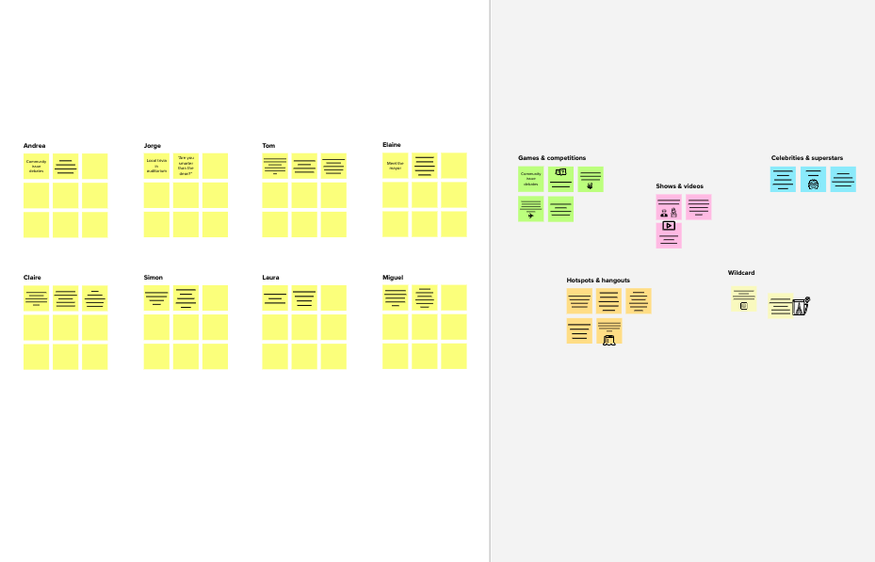

**Template**

**Need some inspiration?**

See a finished version of this template to kickstart your work.

[**Open example**](https://app.mural.co/template/e5a93b7b-49f2-48c9-afd7-a635d860eba6/93f1b98d-b2d2-4695-8e85-7e9c0d2fd9b9)

|  |  |  |  |  |
| --- | --- | --- | --- | --- |
|  |  |  |  |  |
|  |  |  |  |  |